**Supplementary materials**

**Methods**

***Participants***

The following figure illustrates the inclusion/exclusion criteria at each stage of data analysis.



**Figure S1.** The data from SPINS recruited 557 participants with 485 eligible participants (300 for SSDs and 185 for Controls). We excluded data for statistical analysis based on quality control (QC) criteria that include screenings of the structural image (i.e., Dashboard QC), the functional magnetic resonance imaging (fMRI) preprocessing outputs (i.e., fMRIPrep/Ciftify QC), and excessive motion captured by framewise displacement (FD). The final sample includes 247 participants with SSDs and 172 healthy controls who have both complete cognitive and resting-state fMRI data.

***MRI Data Acquisition***

MRI data was collected across 6 scanners, including a General Electric Discovery (*N* = 135) and Siemens Prisma (*N* = 30) at CAMH, a General Electric Signa (*N* = 42) and Siemens Prisma (*N* = 97) at ZHH, and a Siemens Tim Trio (*N* = 66) and Siemens Prisma (*N* = 79) at MPRC. To ensure sequence stability over time and minimize inter-site variance, standardized operating procedures were used along with weekly phantom scans. The study also provided objective evidence for inter-site stability (1–3). Due to scanner differences there were slight variations in the parameters for the T1 MRIs: CMH and ZHH used a BRAVO sequence with TR=6.7/6.4 ms, TE=3/2.8 ms, flip angle=8°, field of view=230 mm, in-plane resolution=0.9 mm2, slice thickness=0.9 mm; CMP, MRC, MRP, and ZHP used an MPRAGE sequence with TR=2300 ms, TE=2.9 ms, flip angle=9°, field of view=230 mm, in-plane resolution=0.9 mm2, slice thickness=0.9 mm). The Resting State (RS) scan was also part of a longer multimodal MRI protocol previously described (4).

***Wakefulness during the RS scans***

To verify wakefulness during the RS scans, we collected responses to two questions: “*Did participant appear to fall asleep?*” and “*Did participant report falling asleep when asked?*” Among 172 Controls, 8 participants appeared to have fallen asleep during the scan with 6 of them and another 3 participants reporting it; among the 247 participants with SSDs, 16 appeared to have fallen asleep during the scan with 10 of them and another 5 participants reporting it. Overall, 32 participants (7.64%), including 11 (6.40%) Controls and 21 (8.50%) participants with SSDs, have fallen asleep during the scan.

***MRI Preprocessing***

The fMRI data were preprocessed using fMRIPrep 1.5.8 (5) and Nipype 1.4.1 (6). Anatomical T1-weighted images were corrected for intensity non-uniformity and skull-stripped using ANTs 2.2.0, and brain tissue segmentation was performed by FSL 5.0.9 (7). Brain surfaces were reconstructed using FreeSurfer 6.0.1 (8), For each fMRI run, ANTs (9) was used to perform fieldmap-less distortion correction, and the Freesurfer’s boundary-based registration, with six degrees of freedom, was performed for co-registration of the functional data to the corresponding T1-weighted image. Slice-timing correction and motion correction were performed using MCFLIRT [(FSL 5.0.9) (10)](https://www.zotero.org/google-docs/?XYXBsv).

Following fMRIPrep, the ciftify workflows (11) version 2.3.1 were used to convert the freesurfer reconstructed surfaces to gifti and cifti file formats. The cortical surfaces were realigned to the HCP fsLR templates (12), using sulcal depth using the MSM algorithm [(MSMSulc) (13)](https://www.zotero.org/google-docs/?8OpMDU) and resampled to 32k vertices per hemisphere, and the freesurfer subcortical segmentation was used to define the participants 32k subcortical atlas grey ordinates. The functional data was projected to the 32k surface coordinates using a ribbon constrained method that excludes outlier voxels, with methods similar to those employed by the HCP Pipelines (12).

We dropped the first three TRs for each scan, and performed spatial smoothing with a 2 mm full width at half maximum Gaussian kernel. ‘ciftify_clean_img’ was then used to detrend and band-pass filter (0.01-0.1 Hz) the signals and perform nuisance regression on the data. The nuisance regression model included six head motion correction parameters, mean white matter signal, mean cerebral spinal fluid signal, mean global signal and the square, the derivative, and the squared derivative for each of these regressors (generated by fMRIPrep). We regressed out the mean global signal to reduce the impacts of motion-related and respiratory-related artifacts (14–16).

***Statistical Analysis***

For any participants missing one cognitive measure, data were imputed with the rest of the behavioral variables using the *mice* package in R. To examine group differences in cognition, we first examined the homoscedasticity between groups by *F*-tests and confirmed the normality of each group by Shapiro-Wilk’s test. Next, we examined group differences between SSDs and controls before imputing missing data. We performed the two-sample equal variances *t*-test if the measure showed homoscedasticity between groups, and we performed Welch's unequal variances *t*-test if the groups were heteroscedastic. If either group did not pass the normality test, we performed a non-parametric bootstrap *t*-test, which has no normality assumption of the data.

***Group Differences in all Three Gradients between the SSDs vs. Controls in Relation to Motion***

Given that participants with SSDs are expected to have higher motion in the scanner, we further examined if the group differences between SSDs and Controls are driven by the participants with higher mean framewise displacement (FD). We split the participants into the top-half and the bottom-half movers according to a median split of FD within each participant group. For each half, group differences (SSDs-Control) in gradient scores were examined with two-sample *t*-tests using the linear model approach (i.e., the *lm* function in R) and were corrected for multiple comparisons with a false discovery rate (FDR) approach (*q*<.05).

***Partial Least Squares Correlation (PLSC)***

Partial least squares correlation (PLSC) (17) is a component-based method that is used to examine the association between two sets of variables measuring the same participants. PLSC decomposes the cross-product between the two variable sets. In our analysis, with the variables centered and normalized to have sums of squares of 1s, such cross-product gives scaled correlations between the two sets of variables. PLSC then decomposes such cross-product matrix into uncorrelated *dimensions* that best capture different components of the correlation pattern. In PLSC, each dimension is composed of 1) two sets of *latent variables*, which represent the participants on this dimension, with respect to the two sets of variables (i.e., behavioral and gradients), and 2) two sets of variable *loadings*, which describe how they contribute to this dimension.

Formally, latent variables are new variables obtained by linear combinations (weighted sums) of the original variables. Each dimension of PLSC includes one pair of latent variables—one obtained from each data table—and the coefficients used to compute these linear combinations are the variable loadings. In PLSC, the first dimension is extracted such that the pair of latent variables are as similar as possible, as measured by their covariance; this covariance is quantified by the first *singular value* of PLSC. Subsequently, the latent variables of the second dimension are obtained from the residual data of the first dimension and explain the maximum covariance from the residual data with this covariance stored as the second singular value. Subsequent dimensions are obtained in the same way. Together, PLSC dimensions explain the covariance of the data tables in descending order and are orthogonal to each other. Given such orthogonality, these dimensions explain independent sources of covariance, and the squared singular values (i.e., the *eigenvalues*, denoted by *λ*) are thus additive. Specifically, they add up to the total squared scaled correlation of the two data tables, and the ratio of each eigenvalue to this total quantifies the proportion of scaled correlation explained by each dimension (denoted by *τ*). As *τ* is similar to the idea of a proportion of variance explained as measured by *η*2, *τ* can be interpreted as the effect size of a PLSC dimension.

**Identify reliable dimensions.** To identify reliable dimensions, we performed a permutation test on the singular values to determine if the covariance between the corresponding pair of latent variables is reliably larger than 0. In the permutation test, we first permuted the participants within each variable of both tables such that the relationships between them were null. The permuted tables were then analyzed by PLSC to extract the first singular value. This procedure was repeated 1000 times to generate the null distribution of the first singular value. For the second dimension, the first dimension was first regressed out from the data before the 1000 iterations of permutation and PLSC to obtain the null distribution of the second singular value; a similar procedure was used for subsequent dimensions. Just like in the null hypothesis testing, we then compared the observed values to their corresponding null distribution and obtained their *p*-value as the probability associated with each observed value under their null. A singular value with *p* < .05 indicates a reliable dimension (*α* = .05).

**Identify important variables and reliable loadings.** To identify important variables for a given dimension, we quantified the *contribution* of each variable by computing the ratio of its squared loading to the eigenvalue. Because each variable was first normalized to have a sum of squares of 1, it originally contributed 1/*J* of variance to the total variance of the data table (with *J* being the number of variables). A contribution larger than 1/*J* therefore marks an important variable as it contributes more than average to the variance of a given dimension.

To identify reliable loadings, we used bootstrap tests to estimate the stability of the loadings. The bootstrap procedure generates a sampling distribution of the given measure (here, the loadings) assuming that the current sample is the best approximate of the population. Therefore, the bootstrap procedure generates subsamples from the original data set to estimate how the given measure varies. In the bootstrap procedure of PLSC, the participants were resampled with replacement to reconstruct the two resampled data tables. These two tables were centered by the original variable means and normalized by the original variable sums of squares then analyzed by a PLSC to generate the loadings. This procedure was repeated 1000 times to generate the bootstrapped sampling distribution of all loadings. The reliability was then quantified by the *bootstrap ratio* (BR), which was computed by dividing each loading by the standard deviation of its bootstrapped sample distribution. Mathematically, BR is a *Z*-approximate that indicates whether the observed loading is reliably different from 0. Therefore, just like the *Z* test, a BR of 1.96 was used as the critical value to indicate reliability at *α* of .05. In this paper, regarding the excessive number of tests, we used a more stringent critical value of 2.88 for two-tail *Z* tests at *α* < .005.

**Reliability of the PLSC model.** To examine the reliability of the PLSC results, we performed standard 10-fold cross-validation (CV). To perform a 10-fold CV, we randomly separated the sample into 10 groups (i.e., folds) with even (or close-to-even) numbers of participants. To ensure that the group structure of the sample in each fold remains unchanged, we first delineated 10 even groups separately from the Controls and the SSDs group and then combined them to create the complete fold. In the CV procedure, one fold (thus 10% of the sample) was left out as the test set, and PLSC was performed on the remaining 90% of the data (i.e., the training set). The resulting PLSC model was then used to predict the 10% out-of-sample. Formally, the prediction includes 2 steps: (1) all variables from the testing set were first normalized by the means and sums of squares of these variables from the training set, and (2) the predicted latent variables of the testing set were computed by multiplying the normalized variables with the corresponding loadings estimated from the training set. This procedure was iterated through all 10-folds and resulted in two sets of the predicted latent variable and 10 sets of loadings for each table.

To evaluate the performance of the CV, we performed two sets of correlations. First, for each table, we tested Pearson’s correlation between the predicted and the observed latent variables. Second, for each table, we computed the mean and standard deviation (SD) of Pearson’s correlations between the observed loadings and the 10 sets of loadings estimated from all testing sets. To avoid over-estimating the CV performance with a high train-test ratio (90%-10%), we also performed a 4-fold CV, where 4, instead of 10, even folds were generated with a lower train-test ratio (75%-25%).

**Results**

***Lower Within-Network Differentiation in the Default Mode Network (DMN) Across Gradients in SSDs vs. Controls***

Although participants with SSDs have reliably higher gradient scores compared to Controls for ROIs from the default mode network (DMN), these ROIs have different patterns from those of the other networks. Descriptively, the ROIs from other networks showed lower differentiation between networks for participants with SSDs, whereas the ROIs from DMN showed lower differentiation within the network for participants with SSDs, as indicated by red arrows moving towards each other or the mean scores in **Figures 2B**-**2D**, **S4** and **S5**. Similar to Gradient 1, we also see lower within-network differentiation in DMN (see **Figures S4** and **S5**).

Given the heterogeneity of ROIs in the DMN, it is worth noting that these identified DMN ROIs identified for Gradient 1 are those that are located closer to the visual networks in the brain. On Gradient 2, the identified ROIs within DMN were those medial regions located closer in the brain to FPN and temporal regions located closer in the brain to VIS.

***PLSC*** ***cross-validation***

The 10-fold cross-validation showed significant reliability of the PLSC model with high correlations between the original and the predicted latent variables (LV) (Cognitive LV1: *r* = .9997, *p* < .0001, Gradient LV1: *r* = .98, *p* < .0001), and between the original and the predicted loadings (Cognition: *r* across folds = [.98, .99] with the mean (SD) of *r* = .99 (0.0053), Gradient: *r* across folds = [.97, .99] with the mean (SD) of *r* = .98 (0.0078)). The proportion of variance explained by the first PLSC dimension, across all folds, has range = [.64, .69] with a mean (SD) = .67 (.02).

To avoid over-estimation with a high train-test ratio (90-10), we also performed another cross-validation with 4 folds, which put the train-test ratio at (75-25). The reliability was confirmed in this cross-validation with high correlations found in LVs (Cognitive LV1: *r* = .9995, *p* < .0001, Gradient LV1: *r* = .97, *p* < .0001) and in loadings (Cognition: *r* across folds = [.97, .99] with the mean (SD) of *r* = .98 (0.01), Gradient: *r* across folds = [.94, .95] with the mean (SD) of *r* = .95 (0.003)). The proportion of variance explained by the first PLSC dimension, across all folds, has range = [.64, .67] with a mean (SD) = .65 (.01).

***Lower Differentiation Across all Three Gradients in SSDs vs. Controls for both the Top-Half and the Bottom-Half Movers***

**Figure S6A** illustrates the boxplot of each group from the top-half and the bottom-half movers with descriptive statistics shown in **Figure S6B**. The results from independent two-sample *t*-tests show a significant group difference in mean FD within the top-half movers, *t*(207.34) = 2.56, *p* = .01, but the group difference within the bottom-half movers is not significant, *t*(179.54) = 0.67, *p* = .50. It is worth noting that the effect of mean FD, along with age and sex, has been regressed out from the gradient data for the following analysis.

Significant group differences in gradients across the brain regions are shown in **Figure S7A** and illustrated by arrows representing each region of interest (ROI) in **Figure S7B**-**S7D** pointing from the top-half movers of the Control group to the top-half movers of the SSDs group along all three dimensions. **Figure S7E** showed the same results for the bottom-half movers of the Control group and of the SSDs group with **Figure S7F-S7H** illustrating the changes from the Controls to the SSDs group along all three dimensions. Compared to the overall results, similar patterns of lower differentiation were found in both the top-half and the bottom-half mover groups. They both showed lower differentiations at FDR-corrected *α=*0.05 along all three gradients, with more regions found significant in the top-half mover group. These results suggested that the observed gradient constraints, although affected, were not due to motion effects.

***Separate PLSCs for Controls-Only and SSDs-Only Identified Similar Cognition-Gradient Associations***

To understand if the observed cognition-gradient association was a general relationship or a specific one for SSDs, we performed separate PLSCs to examine these associations within each group. The results are shown in **Figure S8**, referencing **Figure 3** for the same results when the two groups are combined. Results showed that the first PLSC dimensions from both separate PLSCs identified the general association between cognitive performance and the gradients (**Figures S8A-S8B** and **S7D-S8E**). From these two PLSCs, we identified different contributing brain region gradients, partly in different directions (**Figures S8B** and **S8E**). However, when we masked the contributing gradients according to the original combined PLSC, **Figures S8C** and **S8F** showed a consensus of the contributing gradients. This result suggests that there are specific ROI gradients for the participants with SSDs, but common gradient ROI contributions were identified with a larger sample size boosting the power of the analysis. In addition, although the contributing gradients identified in the combined PLSC were found in both groups when considered separately, they still significantly differentiated the two groups (**Figure 3C**).

**Table S1. Clinical characteristics of the SSDs group (*n* = 247).**

|  |  |  |  |
| --- | --- | --- | --- |
|  | *n* (%) | Mean (SD) | Range  [*min*, *max*] |
| Diagnoses |  |  |  |
| Schizophrenia | 180 (72.87%) |  |  |
| Schizoaffective Disorder | 48 (19.43%) |  |  |
| Psychotic Disorder NOS | 13 (5.26%) |  |  |
| Schizophreniform Disorder | 6 (2.43%) |  |  |
| Age of onset (year) |  | 20.46 (4.88)† | [5, 40] |
| Duration of disease (year) |  | 10.98 (9.93) † | [< 1, 42] |
| Number of hospitalizations |  | 4.14 (6.15)‡ | [0, 25] |

*Note:* Sample sizes (*n*) are reported separately as the age of onset, the duration of disease, and the number of hospitalizations have different numbers of missing values. For the number of hospitalizations, 13 participants reported “Too Many,” and their values were replaced by the maximum number reported by the rest of the SSDs group. NOS: Not Otherwise Specified. †: 246 participants with available data. ‡: 223 participants with available data.

**Table S2. Clinical Characteristics of the SSDs group (*n* = 247).**

|  |  |  |  |
| --- | --- | --- | --- |
| **Antipsychotic** | *n* (%) | **Non-Antipsychotic** | *n* (%) |
| clozapine | 59 (24.58%) | alprazolam | 1 (0.42%) |
| fluphenazine | 10 (4.17%) | atomoxetine | 1 (0.42%) |
| haloperidol | 14 (5.83%) | benztropine | 29 (12.08%) |
| iloperidone | 1 (0.42%) | bromazepam | 1 (0.42%) |
| loxapine | 3 (1.25%) | bupropion | 13 (5.42%) |
| lurasidone | 8 (3.33%) | buspirone | 5 (2.08%) |
| methoprazine | 1 (0.42%) | citalopram | 11 (4.58%) |
| olanzapine | 40 (16.67%) | clomipramine | 5 (2.08%) |
| paliperidone | 21 (8.75%) | clonazepam | 32 (13.33%) |
| periciazine | 1 (0.42%) | dextroamphetamine | 2 (0.83%) |
| perphenazine | 5 (2.08%) | diazepam | 1 (0.42%) |
| quetiapine | 26 (10.83%) | divalproex | 1 (0.42%) |
| risperidone | 41 (17.08%) | doxepin | 1 (0.42%) |
| thiothixene | 2 (0.83%) | duloxetine | 2 (0.83%) |
| ziprasidone | 6 (2.5%) | escitalopram | 16 (6.67%) |
|  |  | eszopiclone | 1 (0.42%) |
|  |  | ethopropazine | 1 (0.42%) |
|  |  | fluoxetine | 8 (3.33%) |
|  |  | flupentixol | 5 (2.08%) |
|  |  | gabapentin | 3 (1.25%) |
|  |  | guanfacine | 1 (0.42%) |
|  |  | hydroxyzine | 3 (1.25%) |
|  |  | lamotrigine | 9 (3.75%) |
|  |  | leuprorelin | 1 (0.42%) |
|  |  | lisdexamfetamine | 1 (0.42%) |
|  |  | lithium | 13 (5.42%) |
|  |  | lorazepam | 25 (10.42%) |
|  |  | methylphenidate | 3 (1.25%) |
|  |  | minocycline | 1 (0.42%) |
|  |  | naltrexone | 1 (0.42%) |
|  |  | oxcarbazepine | 1 (0.42%) |
|  |  | paroxetine | 4 (1.67%) |
|  |  | sertraline | 24 (10%) |
|  |  | topiramate | 1 (0.42%) |
|  |  | trazodone | 10 (4.17%) |
|  |  | trifluoperazine | 1 (0.42%) |
|  |  | valproate | 15 (6.25%) |
|  |  | venlafaxine | 10 (4.17%) |
|  |  | vortioxetine | 1 (0.42%) |
|  |  | zopiclone | 2 (0.83%) |

*Note:* Some participants with SSDs were on more than 1 medication, whereas 13 (5.42%) participants with SSDs were not medicated.

**Table S3.**

|  |  |  |  |  |
| --- | --- | --- | --- | --- |
|  | Correlation with  Cognitive Scores | | Correlation with  Brain Scores | |
|  | *r* [95% CI] | *q*(FDR) | *r* [95% CI] | *q*(FDR) |
| Birchwood Social Functioning Scale (BSFS) | -.14 [-.27, -.01] | .044 | -.17 [-.30, -.04] | .015 |
| Quality of Life Scale (QLS) | -.32 [-.43, -.19] | < .001 | -.25 [-.37, -.12] | .001 |
| Brief Psychiatric Rating Scale (BPRS) | .08 [-.05, .21] | .26 | .05 [-.08, .18] | .468 |
| Scale for the Assessment of Negative Symptoms (SANS) | .19 [.06, .31] | .01 | .21 [.08, .33] | .005 |

*Note:* Two participants with missing values for QLS and two participants with missing values for SANS are removed from the analysis.

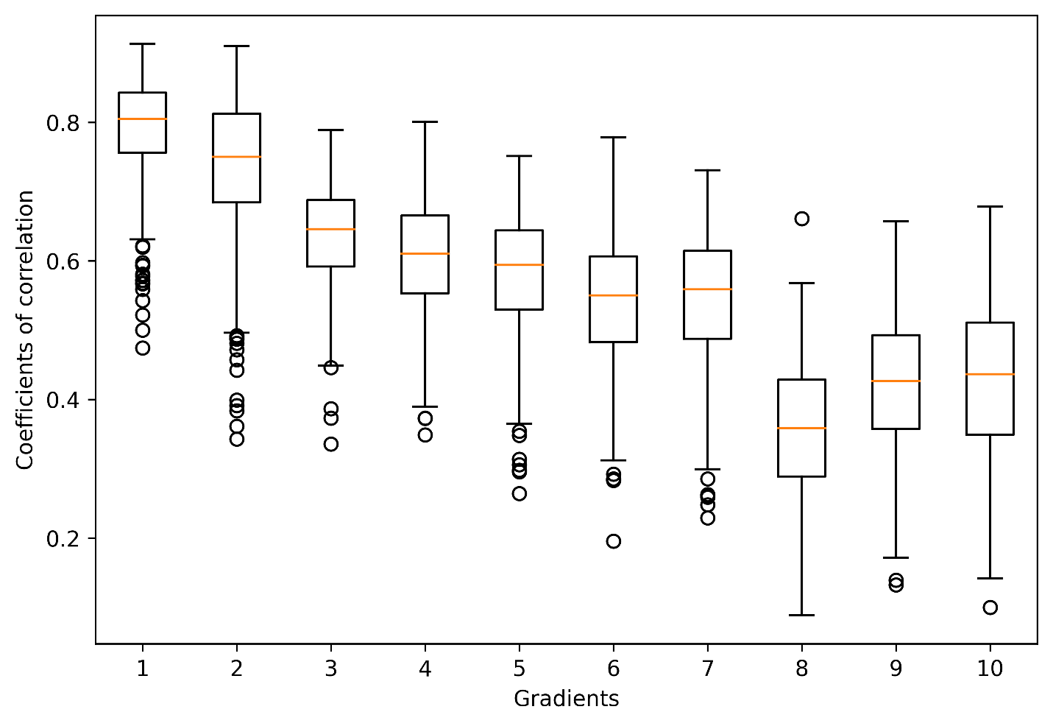

**Figure S2.** Boxplots of the Pearson’s correlation which quantify the goodness of fit of the Procrustean rotation of each participant to the gradient map from Margulies et al. (2016) for all 10 extracted gradients. The mean (SD) of the coefficients of correlation of each gradient are: .79 (0.07), .74 (0.10), .64 (0.07), .6 (0.08), .58 (0.09), .54 (0.09), .54 (0.09), .36 (0.09), .42 (0.10), .43 (0.11).

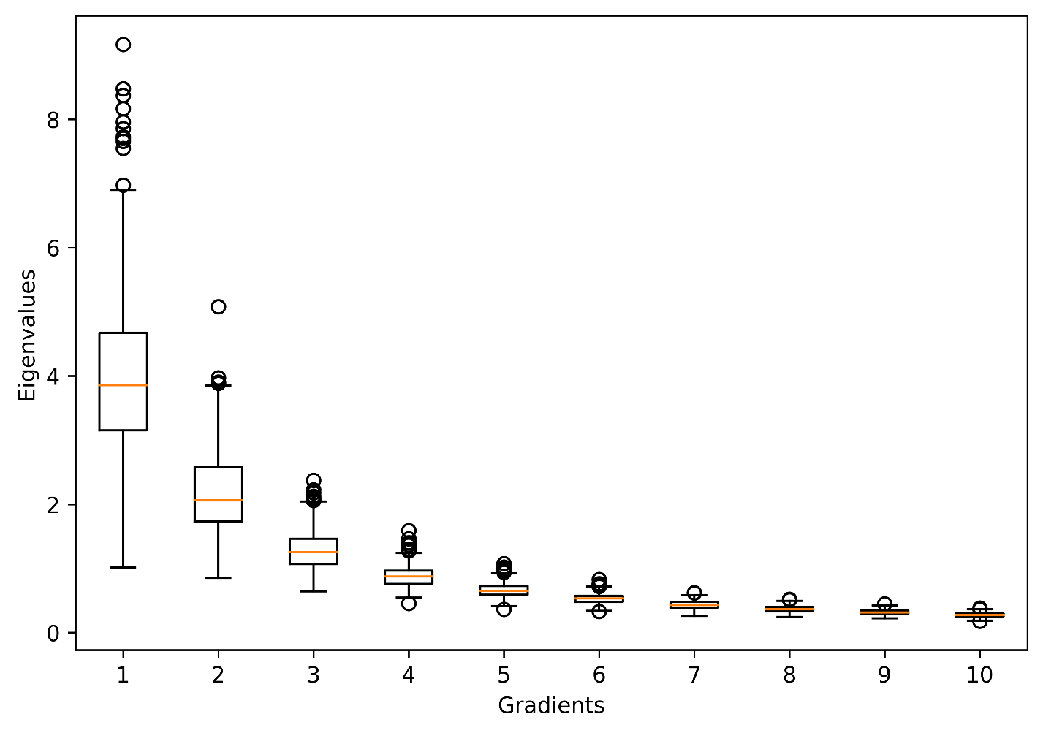

**Figure S3.** Boxplots of the eigenvalues from the first 10 dimensions extracted by the gradient analysis.

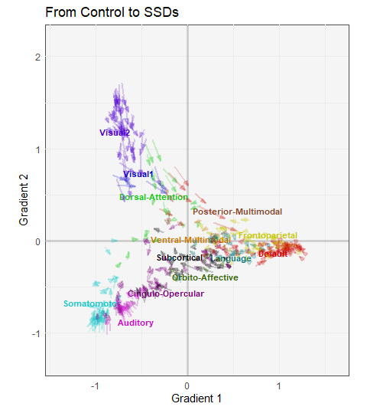

**Figure S4.** The scatter plot illustrates the group differences of each brain region on Gradients 1 and 2. In this plot, each arrow represents a region of interest (ROI) pointing from the mean gradient scores of the Control group to that of the SSDs group. These arrows are colored by networks according to the Cole-Anticevic cortical atlas with the labels positioned at the mean gradient scores of each network. Specifically, this figure shows how ROIs from the default mode network (DMN), as compared to other networks, have lower within-network, rather than between-network, segregation in SSDs as all red arrows are pointing towards the network mean.

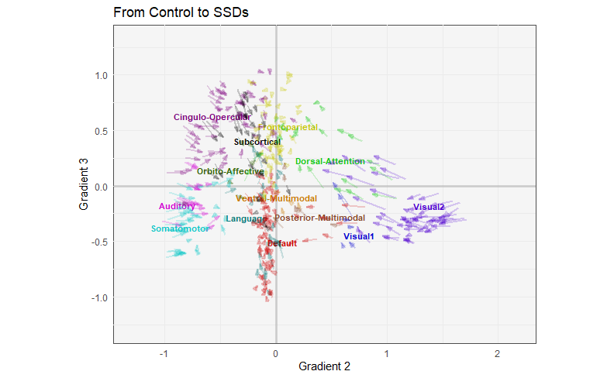

**Figure S5.** The scatter plot illustrates the group differences of each brain region on Gradients 2 and 3. In this plot, each arrow represents a region of interest (ROI) pointing from the mean gradient scores of the Control group to that of the SSDs group. These arrows are colored by networks according to the Cole-Anticevic cortical atlas with the labels positioned at the mean gradient scores of each network. Specifically, this figure shows how ROIs from the default mode network (DMN), as compared to other networks, have lower within-network, rather than between-network, segregation in SSDs as all red arrows are pointing towards the network mean.

|  |  |
| --- | --- |
| **A** | **B** |
|  | |  |  |  | | --- | --- | --- | |  | **Mean FD** | | |  | Mean (SD) | Range | | ***Top-half movers*** | | | | SSDs | 0.22 (0.12) | [0.12, 0.50] | | Control | 0.20 (0.07) | [0.12, 0.46] | | ***Bottom-half movers*** | | | | SSDs | 0.09 (0.02) | [0.04, 0.12] | | Controls | 0.09 (0.02) | [0.05, 0.12] | |

**Figure S6. Descriptive statistics of the top-half and the bottom-half movers.** **A** illustrates the boxplot of mean framewise displacement (FD) for each group within the top-half and the bottom-half movers. **B** shows the means, the standard deviations (SD), and the ranges of mean FD for each group.

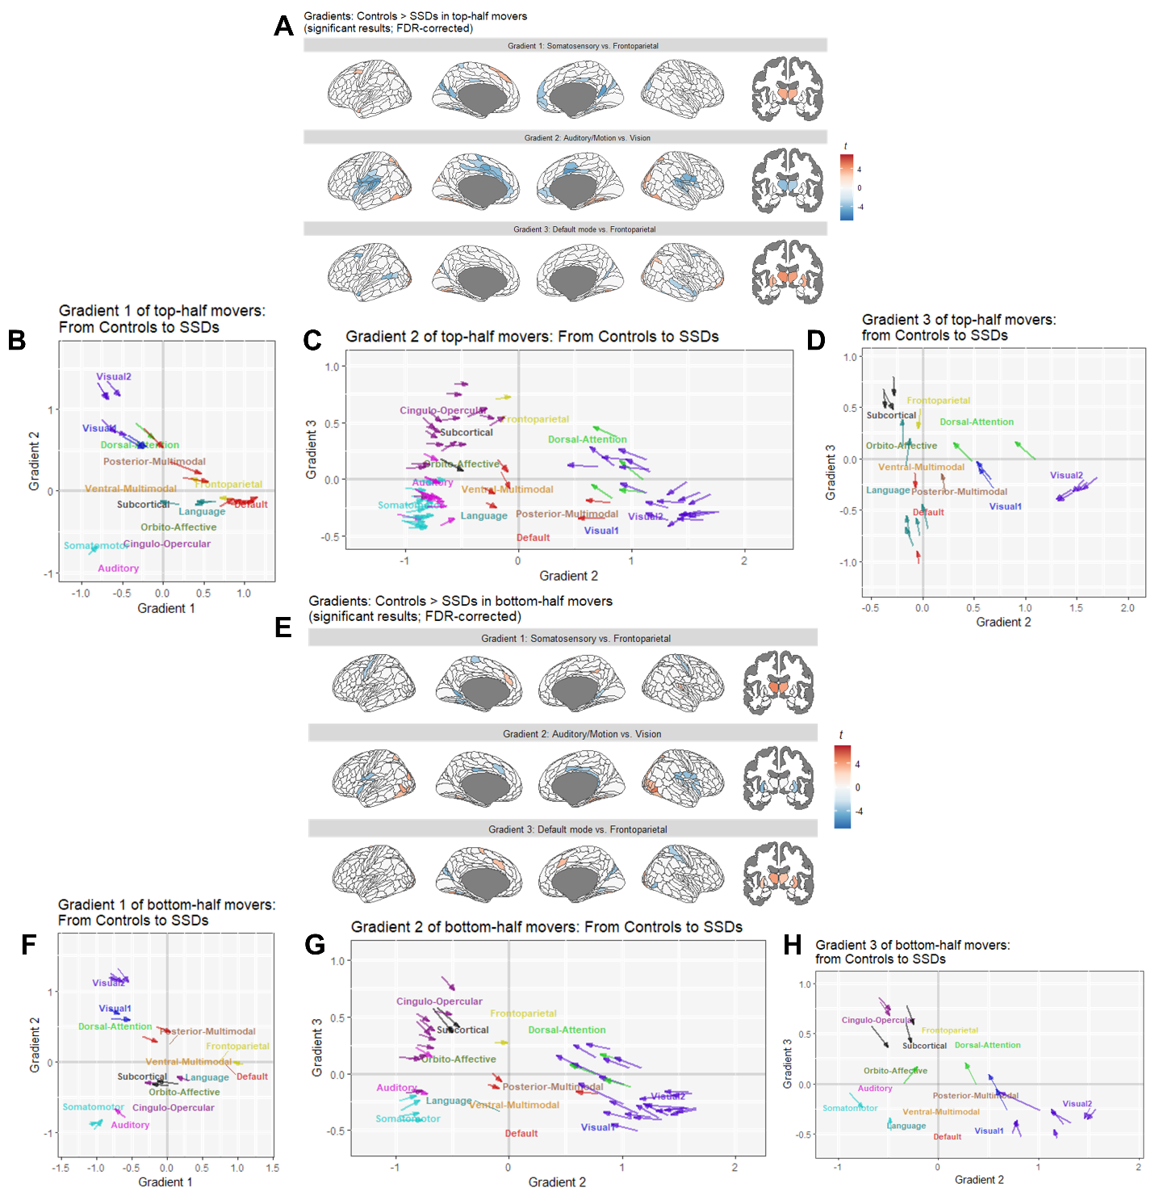

**Figure S7. Group differences in Gradients 1-3 for the top-half and the bottom-half movers. A** shows the brain regions with significant group differences of the top-half movers according to two-sample *t*-tests (as linear models), whereas **E** shows the same results for the bottom-half movers. Warm colors indicate Controls being significantly closer than SSDs to the positive ends of the gradients (i.e., the default/frontoparietal, the visual, and the frontoparietal networks, respectively); cold colors indicate Controls being significantly closer than SSDs to the negative ends of the gradients (i.e., the somatosensory/visual, the auditory/motor, and the default mode networks, respectively). **B**–**D** show the brain regions with group differences between the top-half movers of Controls and the top-half movers of SSDs along Gradients 1–3 in a 3D space; **F**–**H** show the brain regions with group differences between the bottom-half movers of Controls and the bottom-half movers of SSDs along Gradients 1–3 in a 3D space. Significant group differences in a similar set of ROIs were found along Gradient 1 for both the top-half movers (**B**) and the bottom-half movers (**F**), along Gradient 2 (i.e., the x-axis of **C** and **G**) for both the top-half movers (**C**) and the bottom-half movers (**G**), and along Gradient 3 (i.e., the y-axis of **D** and **H**) for both the top-half movers (**D**) and the bottom-half movers (**H**). Each arrow represents one ROI and is colored according to the networks defined by Cole-Anticevic (cortical) and Tian (subcortical) parcellations in **Figure 1A**. The network labels illustrate where the means of the networks are for Controls.

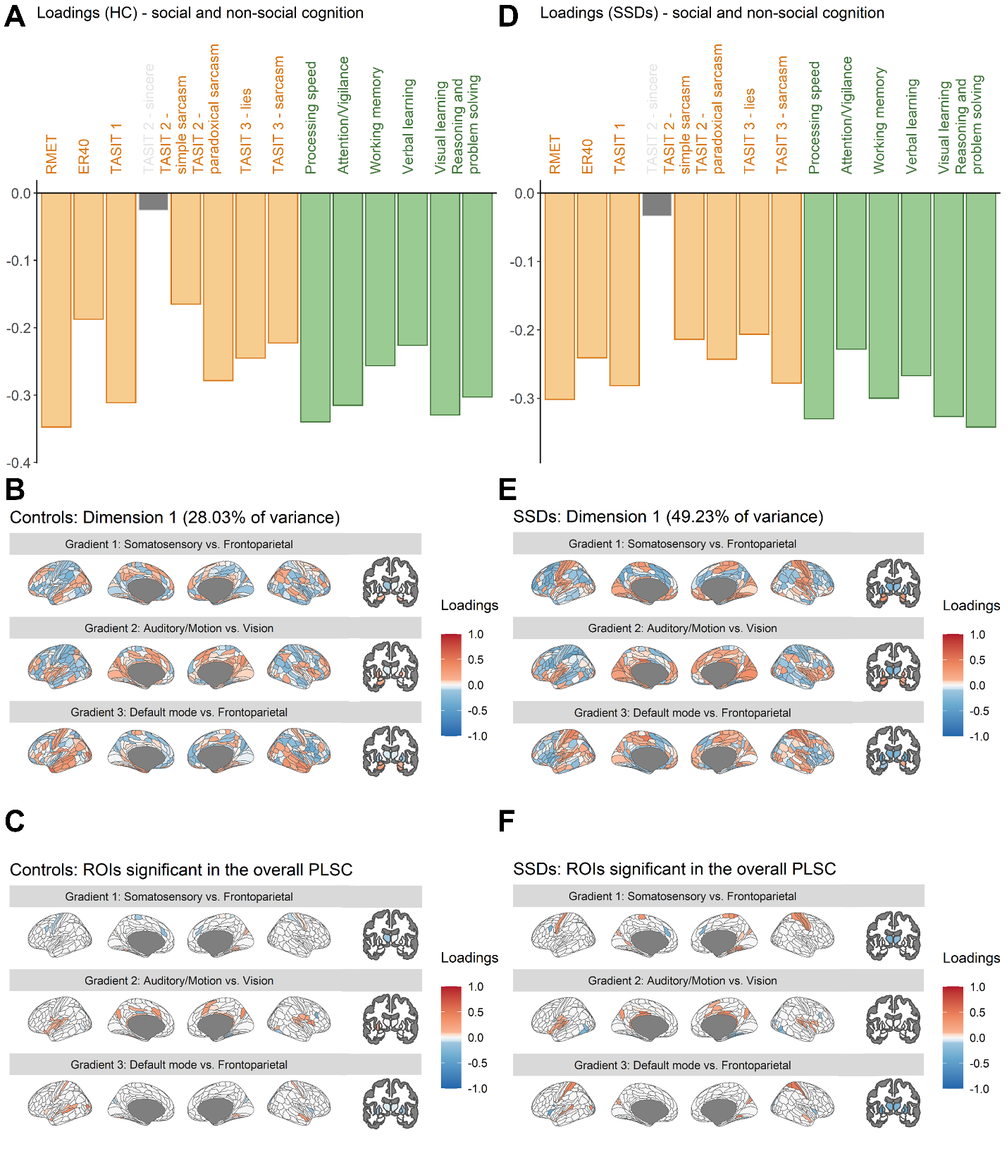

**Figure S8. PLSC results with only Controls or the participant with SSDs. A**-**C** illustrates the loadings from the Controls-only PLSC, and **D-F** illustrates the loadings from the SSDs-only PLSC. The loadings for the cognitive measures (**A** and **D**) and the network hierarchy (**B** and **E**) separately from the two groups both illustrate the general associations of the cognitive measures and the network hierarchy. **C** and **F** showed the loadings, respectively from **B** and **E**, masked by the contributing gradient regions of interest (ROIs) identified by the combined PLSC (**Figure 2B**).

**References**

1. Chavez S, Viviano J, Zamyadi M, Kingsley PB, Kochunov P, Strother S, Voineskos A (2018): A novel DTI-QA tool: Automated metric extraction exploiting the sphericity of an agar filled phantom. *Magn Reson Imaging* 46: 28–39.

2. Hawco C, Viviano JD, Chavez S, Dickie EW, Calarco N, Kochunov P, *et al.* (2018): A longitudinal human phantom reliability study of multi-center T1-weighted, DTI, and resting state fMRI data. *Psychiatry Res Neuroimaging* 282: 134–142.

3. Kochunov P, Dickie EW, Viviano JD, Turner J, Kingsley PB, Jahanshad N, *et al.* (2018): Integration of routine QA data into mega‐analysis may improve quality and sensitivity of multisite diffusion tensor imaging studies. *Hum Brain Mapp* 39: 1015–1023.

4. Viviano JD, Buchanan RW, Calarco N, Gold JM, Foussias G, Bhagwat N, *et al.* (2018): Resting-State Connectivity Biomarkers of Cognitive Performance and Social Function in Individuals With Schizophrenia Spectrum Disorder and Healthy Control Subjects. *Biol Psychiatry* 84: 665–674.

5. Esteban O, Markiewicz CJ, Blair RW, Moodie CA, Isik AI, Erramuzpe A, *et al.* (2019): fMRIPrep: a robust preprocessing pipeline for functional MRI. *Nat Methods* 16: 111–116.

6. Gorgolewski K, Burns CD, Madison C, Clark D, Halchenko YO, Waskom ML, Ghosh SS (2011): Nipype: A Flexible, Lightweight and Extensible Neuroimaging Data Processing Framework in Python. *Front Neuroinformatics* 5. https://doi.org/10.3389/fninf.2011.00013

7. Zhang Y, Brady M, Smith S (2001): Segmentation of brain MR images through a hidden Markov random field model and the expectation-maximization algorithm. *IEEE Trans Med Imaging* 20: 45–57.

8. Dale AM, Fischl B, Sereno MI (1999): Cortical Surface-Based Analysis. *NeuroImage* 9: 179–194.

9. Treiber JM, White NS, Steed TC, Bartsch H, Holland D, Farid N, *et al.* (2016): Characterization and Correction of Geometric Distortions in 814 Diffusion Weighted Images ((J. Najbauer, editor)). *PLOS ONE* 11: e0152472.

10. Jenkinson M, Bannister P, Brady M, Smith S (2002): Improved Optimization for the Robust and Accurate Linear Registration and Motion Correction of Brain Images. *NeuroImage* 17: 825–841.

11. Dickie EW, Anticevic A, Smith DE, Coalson TS, Manogaran M, Calarco N, *et al.* (2019): Ciftify: A framework for surface-based analysis of legacy MR acquisitions. *NeuroImage* 197: 818–826.

12. Glasser MF, Sotiropoulos SN, Wilson JA, Coalson TS, Fischl B, Andersson JL, *et al.* (2013): The minimal preprocessing pipelines for the Human Connectome Project. *NeuroImage* 80: 105–124.

13. Robinson EC, Jbabdi S, Glasser MF, Andersson J, Burgess GC, Harms MP, *et al.* (2014): MSM: A new flexible framework for Multimodal Surface Matching. *NeuroImage* 100: 414–426.

14. Parkes L, Fulcher B, Yücel M, Fornito A (2018): An evaluation of the efficacy, reliability, and sensitivity of motion correction strategies for resting-state functional MRI. *NeuroImage* 171: 415–436.

15. Power JD, Plitt M, Gotts SJ, Kundu P, Voon V, Bandettini PA, Martin A (2018): Ridding fMRI data of motion-related influences: Removal of signals with distinct spatial and physical bases in multiecho data. *Proc Natl Acad Sci* 115. https://doi.org/10.1073/pnas.1720985115

16. Li J, Kong R, Liégeois R, Orban C, Tan Y, Sun N, *et al.* (2019): Global signal regression strengthens association between resting-state functional connectivity and behavior. *NeuroImage* 196: 126–141.

17. Krishnan A, Williams LJ, McIntosh AR, Abdi H (2011): Partial Least Squares (PLS) methods for neuroimaging: a tutorial and review. *Neuroimage* 56: 455–475.